Ec2 challenges

Install Docker.
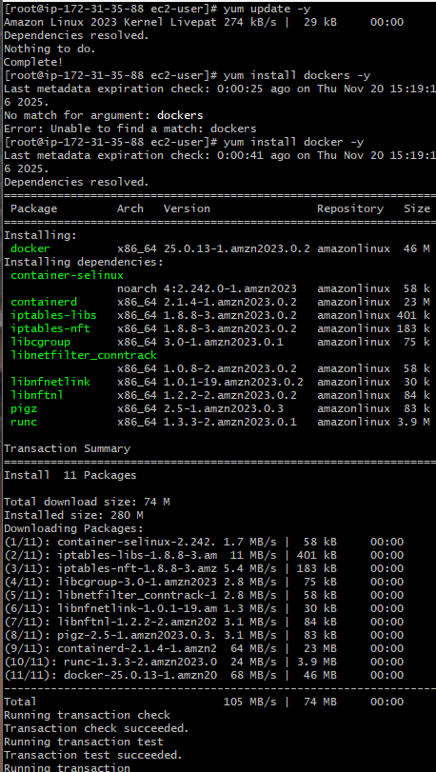
Yum update
Yum install dockers -y
Systemctl start docker
Systemctl enble dockers

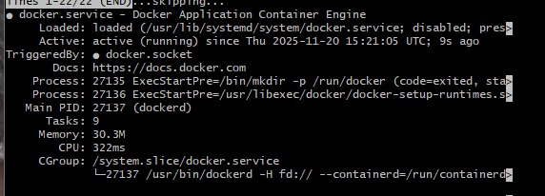

- Install Jenkins.

- Install java (mandatry for jenkins
- Sudo yum install java-17 -a,ozo -corretto-y
- With that package we install jenkins
- Add the offcial jenkins repository
- Weget (past)
- Download the jenkins repo
- Now we can install jenkins package
- Yum install jenkins edited the port go insde jenkins service and change the port number
- Systemctl start jenkins
- Systemcyl status jenkin
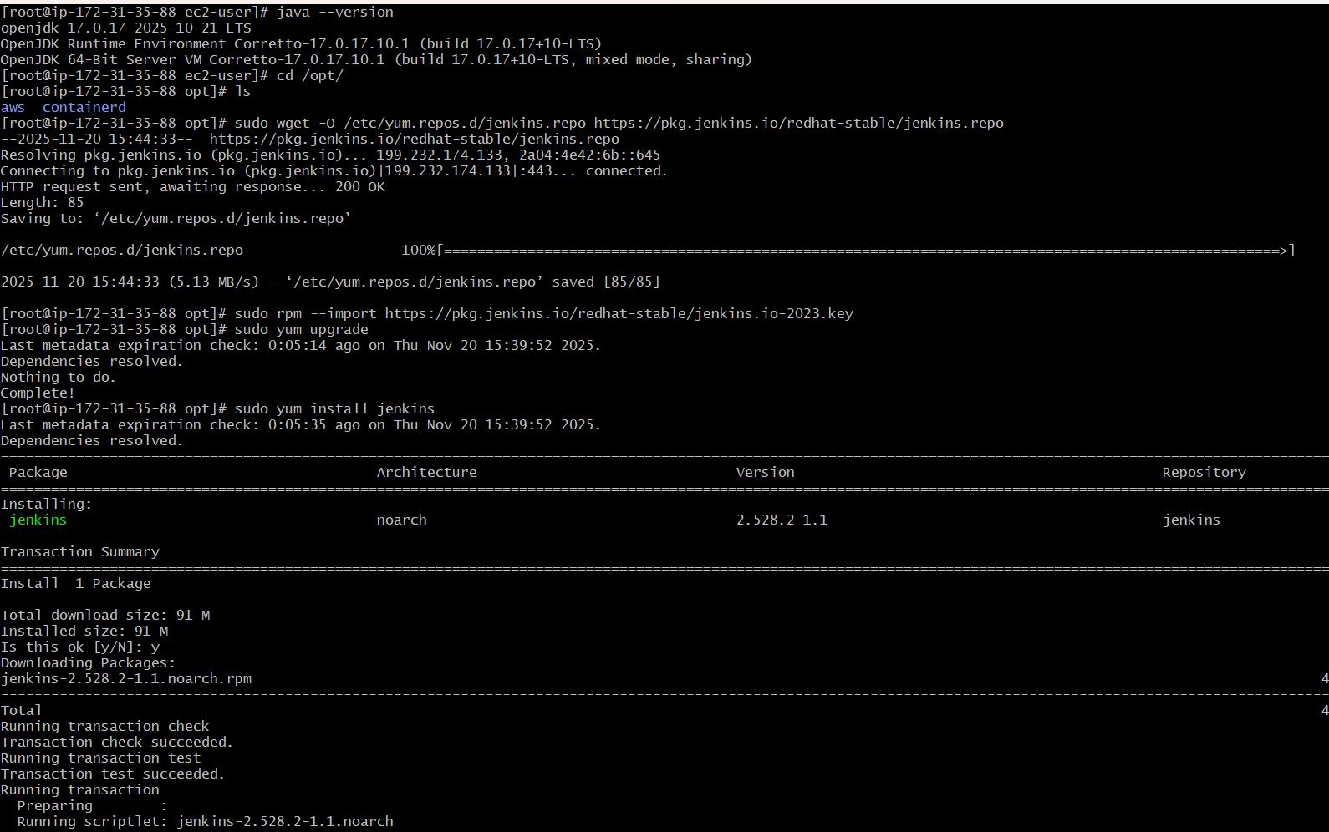
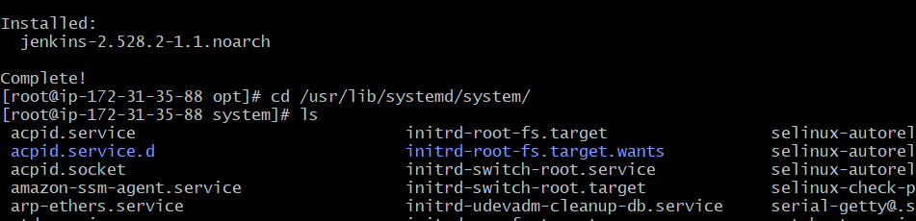
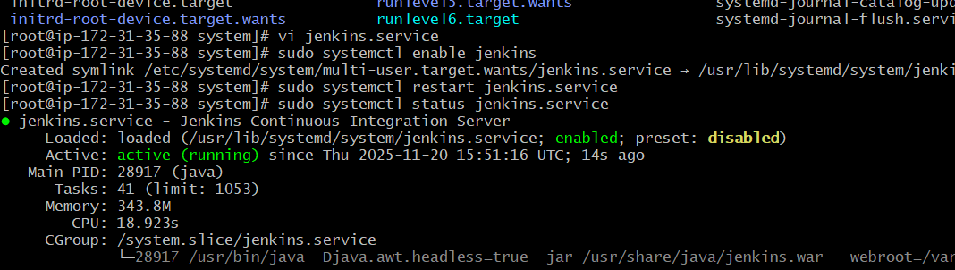
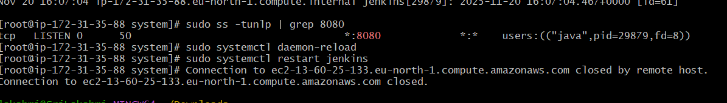

Install Apache Tomcat..
- Java (mandary )
- Use wget (link)
- Tar xvf
- Cd apache tomcat
- Cd bin
- ./startup
- Go and check the local host
- If is not working go to change portnmber
- For the changing port we have go isde of server.xml file
- Tomcat/conf/server.xml
- Change port number (8080 , 9090 …)
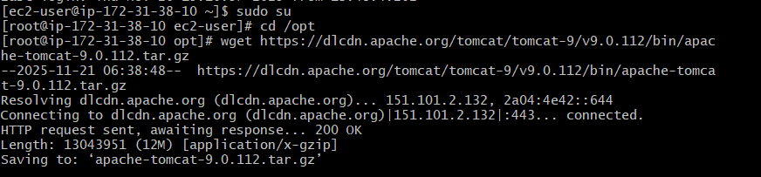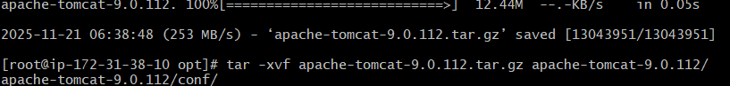
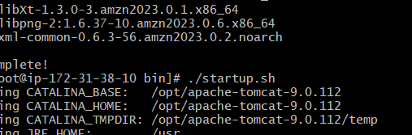
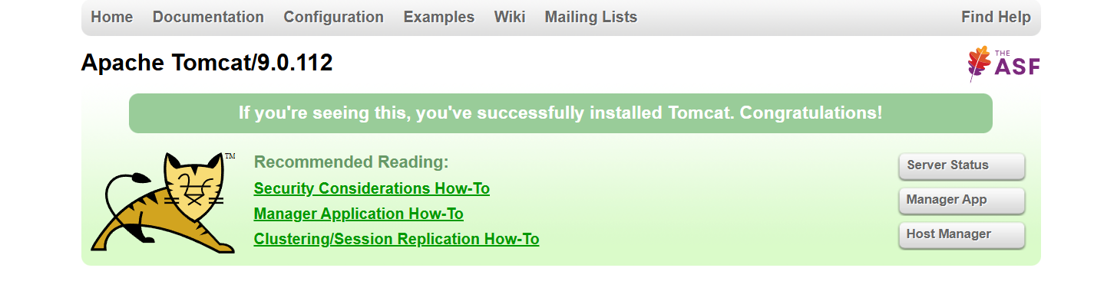

Install Nginx.
- Yum update
- Yum install nginx
- Systemctl start nginx
- Systemctl status nginx
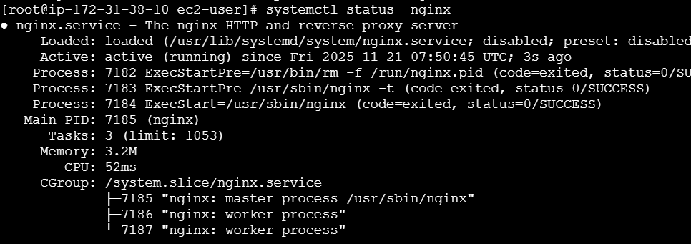
If we want change port this command we used
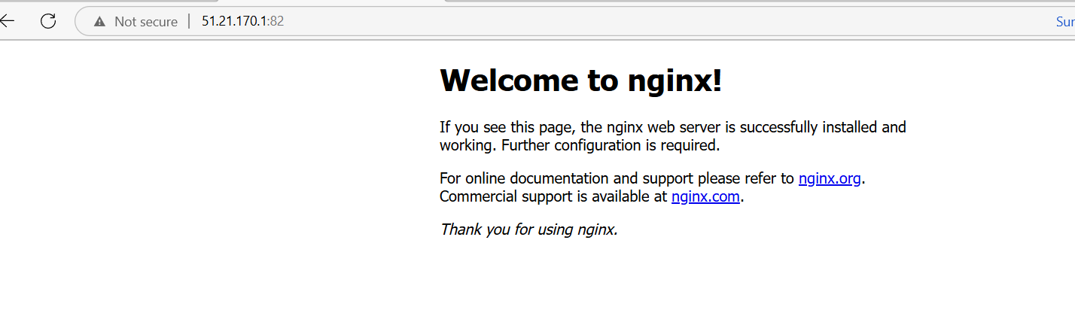
Install apache /httpd
Yum update
Yum install httpd
Systemctl start httpd
Systemctl status httpd
